Technical Report

Design

Frode Karlsen

Word count

Summary: 250 | Main text:500

Table of Contents

1. Summary

2. Body

2.1. Introduction

2.2. Main

2.2.1 Design research

2.2.2 Color wheel

2.2.3 Typography

2.2.4 Navigation Design

2.2.5 Buttons, hover effects etc.

3. References

4. Acknowledgements

# 1. Summary

This report sums up my design process, which includes research, my thoughts and ambitions in terms of the overall design decisions made for Hubspot.

# 2. Body

## 2.1 - Introduction

The main section of this report will break down the process of design decisions I have made for Hubspot. I will touch on branding/logo, typeface, color palette, buttons, icons and images to use for the microsite.

## 2.2 Main

**2.2.1 -Design research**

I will take advantage of the research I’ve already done with the personas I made from the target audience research. That leaves me towards the interests of my personas. My research revealed that my target audience is male, Caucasians that are interested in science and technology. Other interests of this group would be stuff like science fiction, comics, video games, computers, tv-shows and movies.

Fantasy seems to be a red thread of what I am looking at here. I want to capture fantasy into a color chart, the font selection, and my general design concept. NASAs design on their website looks sort of old in my opinion. Dark colours to make the images pop more are definitively something I will keep focus on. So, in short I will focus on fantasy/dreams and make it look cool.

After thinking about it thoroughly, I feel that ‘cyberpunk’ is a pretty cool topic in terms of colors options and general theme. Cyberpunk refers to both a culture and a genre, but is mainly a sub-genre of science fiction that features advanced science and technology in an urban, dystopian future. Short and sweet it’s high tech and low life – a neon dystopia.

The colors you would go for are vibrant, bold and eye catching. At the same time, cyberpunk is futuristic and fits the dreamer aspect of my target audience, and it might appeal to a younger target audience at the same time with a very unique and cool look. This is sort of a unique approach. I don’t want to overdo it though, so I want to keep it a bit toned down in order to keep things professional looking, but maybe put in some flamboyant design decisions for certain aspects of the page to make things “pop”, such as images, call to action, links etc. The branding of Hubspot is supposed to be something exciting and fresh, so that is what I am aiming for with the page.

**2.2.2 - Color wheel**

I looked up cyberpunk and images online, and found a few that matched my vision in terms of colors. I located an image via Google search that I ran through Adobe Kuler.

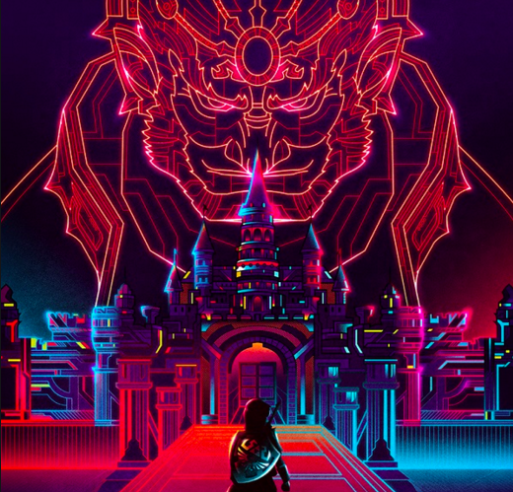

This is the color chart I created from it:

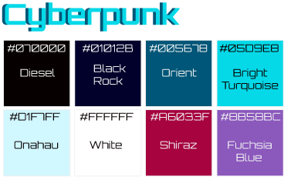

**2.2.3 - Typography**

As for my font selection I want a mix of something that screams sci-fi, and a clean looking font that is easy to read. I made some research online and found a Google font called Orbitron, which is a geometric sans-serif typeface that is intended for display purposes. Orbitron comes in four weights, so it gives me a bit of playing room in that regards. Personally I like the way it looks, as it gives me a sort of sci-fi movie poster feel, which is exactly what I looking for.

To match Orbitron I am going to use Open Sans, which is a very clean and modern sans-serif typeface. This font is highly legible and therefore will be a good counterpart to the futuristic Orbitron. That is really all I have to say in terms of my decisioning when it comes to the typography/font selection. Huge plus that both are supported by Google fonts, which makes implementation of them nice and easy.

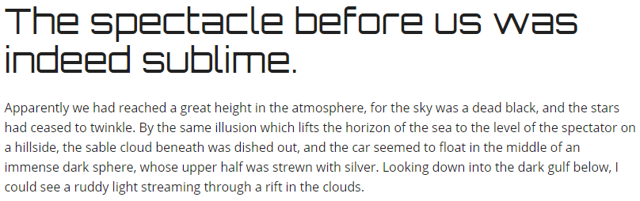

**2.2.4 – Navigation Design**

For this part I am going to have to consider a good structure, minimalism (white space) and overall design.

As for the page structure, I will focus on solid information architecture, with the most important content up top, and the least important content at the bottom of each page. The navigation on each of my pages has an image (banner type image) up top. The landing page one sort of sets itself apart from the rest of them, as it’s supposed to be an interactive menu where you can browse 10 different images and download it. This will only be implemented if I am able to pull it off in terms of coding.

Looking at the rest of the pages, I am happy with the information architecture. Moving on to minimalism and use of white space, I got that nicely covered in the prototype I made. This is something I kept in mind when making the separate pages.

The only thing left is for me to make a separate page containing the launch information. I forgot to make that in the prototype for some reason.

In terms of overall design I will try to keep it as simple as possible. I am going to use a recognizable pattern that goes icon first, followed by an h2 and finally a button for external/internal linking.

Now, I will go back into my prototype and play around with my theme/topic, color wheel and typography to revamp. This will end up in a final prototype that will be my “look” for the page, I still got a couple of days with that before I am going to start coding HTML/CSS base for each of the separate pages.

**2.2.5** **Buttons, hover effects etc.**

Looking at my buttons in the current prototype, I was not overly happy with them. They did not match my theme selection, so I have made some changes to both the prototype itself according to my new design plan and my buttons.

As for the hover effects I am thinking maybe adding some animation.

For the buttons on the page, I want them to be the same color, but when hovering over them I want them to start glowing and to go through an animation of various neon types of colors. This would make the hover effect really unique and cool. I would have to do some research in order to pull this off, but found a few tutorial videos I am going to have a look at when I start programming. Basically, I am looking to make glowing neon buttons that goes through a cool animation when you hover over them. This will get added to references if I decide to give either videos a go.

First off, the hover effects on regular links I am going to use #A6033F because it is a solid, eye catching color to use. It’s grabbing the users attention and pops out from the rest. It’s also to let the user know that it’s clickable:

2020-05-07_1435.png

As for the button design it’s been slightly altered from the initial stale blue color to fit my design concept:



I’ve also added borders, or an <hr> made of 5 circles right below each h2 on the pages to separate the header from the rest of each section:

2020-05-07_1437.png

I have also found a background from pexels.com that I am going to use as a gradient background to fit the theme:

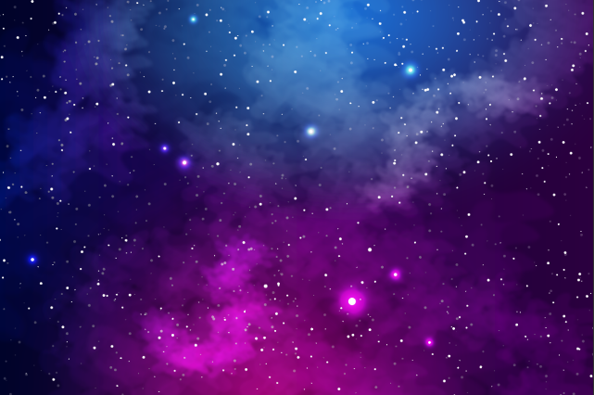

This is how my front page evolved. The rest will follow in terms of looks:

